**Exploring transit service level impacts on the spatial and temporal patterns of micromobility travel**

**Graham Currie**1*, Alexa Delbosc2, Ryan Cox2, Mahesha Jayawardhena2 and James Reynolds1

**1Public Transport Research Group**

**Department of Civil Engineering**

**Monash University, Australia**

**2Institute of Transport Studies**

**Department of Civil Engineering**

**Monash University, Australia**

**\*Corresponding author**

**JEL classification (minimum of 3, maximum 6):**

R41 Transportation: Demand, Supply, and Congestion; Travel Time; Safety and Accidents; Transportation Noise

D90 General

R48 Government Pricing and Policy

**Keywords (up to 8, separated with a semi-colon):**

Micromobility; e-scooter, transit integration; transit service level; mode choice; spatial analysis

# ABSTRACT

This paper explores how public transport and micromobility travel interact using a case study of shared e-scooter users in inner Melbourne, Australia.

The research analyses travel patterns of e-scooter users in relation to Public Transport. A transit service level index is compiled. The spatial and temporal patterns of e-scooter travel are compared with service level to explore the hypothesis that e-scooter use is stronger in areas where inner area transit offers a poorer quality service. This questions if e-scooters act as a ‘gap filler’ to transit providing first-last mile access to transit.

Overall, we find e-scooter demand is highly concentrated in areas and at times when transit service levels are highest. This suggests that shared e-scooters may be competing with transit service rather than filling gaps in service. We therefore conclude that the hypothesis that e-scooters act as a ‘gap filler’ for areas of low transit use is not supported.

Nevertheless, we have found limited and specific evidence of times and areas where ‘gap filling’ and first-last mile trips are apparent. Night time, early morning and weekend e-scooter travel volume is high; all times when transit service levels are lower. We also found limited evidence of spatial gaps in transit where first-last mile rail access was occurring and some evidence that rail-linked e-scooter travel was from lower service level trip ends and that these patterns increased with e-scooter trip distance.

Implications of the research for research and policy are discussed.

# Introduction

Shared e-scooters are the latest innovation in micromobility options available in many inner and downtown parts of cities around the world. While safety concerns have dominated both research (Kazemzadeh et al., 2023) and policy (Bozzi and Aguilera, 2021) responses to the introduction of e-scooters, less attention has focussed on how they might integrate with (or compete with) other inner-city travel modes.

This paper explores links between the spatial and temporal patterns of e-scooter use and public transport services in an inner-city context. The research explores the extent to which e-scooters compete with or complement public transport use. A major focus is on e-scooter trips that might occur at times or locations where public transport service levels are low; hence e-scooter trips might act to complement public transport service. These analyses are undertaken to explore the hypothesis that e-scooter use is stronger in areas where inner area transit offers a poorer quality service. The implication of this hypothesis is that e-scooters may be a ‘gap filler’ in inner area travel providing first-last mile access to transit. The research is also examines trips to/from major rail stations to explore these issues further.

The focus of this paper is shared e-scooter travel patterns in inner Melbourne Australia and an analysis of Lime e-scooter trip patterns. The paper is structured as follows: the next section reviews the research context. This outlines the historical development of e-scooters in inner Melbourne and describes the public transport system around which e-scooters operate. It also reviews the research literature considering e-scooters and public transport. The research methodology is then described followed by a review of research findings. The paper concludes with an outline of key findings and a discussion of their implications for research and practice.

# Research Context

## Micromobility and e-scooters in Melbourne

Micromobility refers to a range of relatively new small, lightweight vehicles operated at relatively low speed (below ~25kph) for personal use in mainly local (short distance) travel in cities. Electric battery powered e-scooters are one of the newer types of micromobility available for either personal ownership, or as part of shared hire schemes typically in downtown or inner city parts of urban areas. E-scooters can be lighter and easier to use compared to bicycles and e-bikes, and appeal to different markets relative to e-bikes (Curl and Fitt, 2020). However, integrating micromobility into the public transport network requires careful planning and policy considerations (Manning and Babb, 2023).

In Melbourne, Australia, a trial of a shared e-scooter and e-bikes has been operating since February 2022. Shared e-scooters are only allowed to operate in the Melbourne Central Business District (CBD) and the inner-city areas of Melbourne City Council, the City of Port Phillip and the City of Yarra (Figure 1). Two separate e-scooter operators, Lime and Neuron, provide shared e-scooters. This paper focusses on e-scooter origin-destination data provided by Lime.

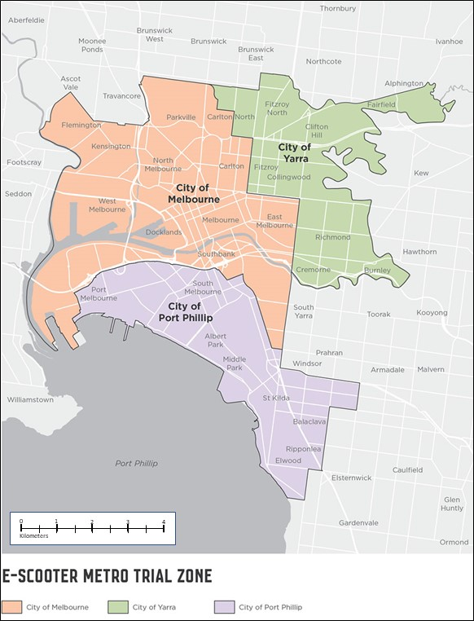

Figure 1: E-Scooter Trial Area (Melbourne City Council, 2024)

## E-Scooters and Inner Melbourne Public Transport

The Melbourne shared e-scooter service area overlaps with inner public transport network including: most of Melbourne’s tram network, key inner-city railway stations and a few bus routes operating in inner Melbourne. Figure 2a illustrates the service level (frequency) of transit stops in inner Melbourne whereas Figure2b shows the distribution of e-scooter trips made on roads in inner Melbourne. Together, the figures illustrate significant overlap between high demand e-scooter roads and the highest quality of service level operating in Melbourne’s public transport system, especially in the central core of the city. This raises a very important question: are shared e-scooters acting to complement or compete with Melbourne’s public transport network?

A survey of Lime users from 2022/2023 explored e-scooter user travel patterns in relation to public transport (Jayawardhena M et al., 2024 Under Review). The analysis suggests that both complementing and competing behaviours are found:

* 37% of e-scooter users connected to public transport before or after their e-scooter trip (complementing behaviour);
* 28% of e-scooter users would have travelled by public transport if the e-scooter was not available (competing behaviour). However, of these users, 45% were using e-scooters to access to/from public transport.

|  |
| --- |
|  |
| 2a. Public Transport Service Level Source: Charting Transport ; [www.chartingtransport.com](http://www.chartingtransport.com) |
|  |
| 2b. E-Scooter rider volume 2022-23  Source: Melbourne City Council (2024) |

Figure 2: Inner Melbourne Transit Service Level and E-Scooter Route Trip Volume

## The Research Literature

The research literature has mixed conclusions regarding the extent to which e-scooters act to compete with or complement public transport ridership, with some overlap between the two positions. The ‘compete’ argument (Aarhaug et al., 2023, Ziedan et al., 2021) suggests e-scooters are used in preference to transit when transit use is uncompetitive due to long wait times or would involve indirect trips, including trips involving transfers. The ‘complementary’ argument suggests e-scooter act as a first or last mile connection to transit nodes such as stations (Tyndall, 2022, Ziedan et al., 2021, Zuniga-Garcia et al., 2022). Other authors (e.g. Luo et al., 2021) note that e-scooter use is beneficial to riders by proving travel options when buses are not running (a complementary role) but also when bus routes are indirect or circuitous, or when waiting time are long (a competing role). In this way benefits emerge to e-scooter users under both compete and complementary roles. A major concern for policy is that e-scooter trips that compete with transit act to erode its ridership (and revenue) base. While this benefits e-scooter users it erodes the sustainability of public transport and might increase the public funding needed for transit subsidies.

# Methodology

The overall aim of the paper is to explore e-scooter travel patterns and how they relate to temporal and spatial patterns of public transport service levels. Key to this analysis are:

* Data on e-scooter travel patterns
* Measures of Public Transport Service Level
* Analytical approaches to exploring spatial and temporal analysis.

## E-Scooter Travel Pattern Data

Lime provided geo-coded trip start and trip end location data for all e-scooter trips made in October 2022 for the inner Melbourne network. For each trip it was possible to identify start and finish time, and location. However trip purpose, ticket type, payments and rider demographics were not available.

A total of 98,355 separate e-scooter trips are recorded in the data for October 2022, suggesting an average of 3,172 trips per day. Data was spatially aggregated to the Australian Bureau of Statistics’ SA1 (Statistical Area 1) zone level. This is the smallest zone or ‘basic spatial unit’ where a full range of demographic and travel data are measured during the census.

## Measure of Public Transport Service Level

To compare e-scooter ridership to transit service, we used a service level measure that includes:

* the quantity of service supplied i.e. the frequency and number of services for a given time period; as well as
* the spatial coverage of services considering walk access distances to transit stops/nodes and stations.

To match the requirements of the spatial analysis scheme service levels needed to be aggregated for each SA1 and for each hour of an average weekday and weekend day.

The Transit Service Index (SI) methodology for measuring service level was adopted using the General Transit Feed Specification (GTFS) files for Melbourne which are provided for input to online journey planners such as Google Maps.

The Transit Service Index (SI) is based on a methodology developed in (Currie G, 2010) and uses the following formulae:

 **Formula 1**

where:

SICCD = Supply Index for the CCD

CCD = Area under analysis

N = number of walk access buffers to stops/stations in each CCD

Bn = Buffer n for each stop/station in each CCD

Area = square kilometre spatial area of the CCD

SL = Service Level Measure (number of bus/tram/train vehicle arrivals per time period)

In effect spatial coverage of an area is computed by GIS software and is the ratio of the walk catchment to nodes to areas in the zone without walk access. This ratio is applied to the cumulative number of service departures at all transit nodes within the zone. The walk buffers applied to measure walk catchments are:

* + Access to Bus Stop = 400m
  + Access to Tram Stop = 400m
  + Access to Rail Station = 800m

The computation for the SI index adopted the 2023 version of the GTFS file and adopted the R analysis package. This is a different year to the 2022 e-scooter usage data, but service levels will not have significantly varied between the two years.

The output SI index is a number representing the average number of transit departures per hour in each SA1 zone factored by the ratio of spatial coverage of the zone. Since coverage was full in CBD or downtown zones and service levels in the peak periods were very frequent average SI scores of up to 300 were output in these zones. However, many zero values result for early hours (1a.m.; 2a.m.) and also for remoter inner area zones with poor access to transit (such as the container Port of Melbourne).

## Analytical Approach

Four perspectives are adopted to explore the research aims:

1. Temporal (per hour) comparison of e-scooter demand and relative public transport service level. This was undertaken separately for weekday and weekend day. The analysis aims to explore if e-scooter trips are being made when there is less service available by public transport.
2. Spatial analysis of e-scooter demand and relative service levels. Mapping of e-scooter trip end demand levels and also public transport SI scores was adopted to illustrate demand spatially. Since SA1 zones were the unit of spatial analysis, choropleth mapping was adopted. A complicating factor in implementing this is that SA1 zones are differing sizes and so very large zones can attract more travel. To account for this, trip density mapping was also adopted to explore the spatial density of travel given relative zone size.
3. E-scooter trips to/from rail stations – e-scooter trips starting or finishing within 30 metres of a rail station exit were designated as likely rail feeder e-scooter trips. The spatial and temporal distribution of these trips were explored to see if their patterns varied compared to non-station related e-scooter trips.
4. Change in service level score between e-scooter trip ends. Here the difference in public transport service levels at the start and end of e-scooter trips were measured. If the difference is large, it implies the travel is made from either a low to a high service level area or vice-versa. The implication is that e-scooters are being used to access higher service level nodes and/or to travel from areas with low service levels. Analysis sought to explore how this varies with trip distance and also between station related e-scooter trips and non-station related e-scooter trips.

# Results

## Temporal comparison of e-scooter demand and transit service level

Figure 3a shows the distribution of e-scooter trips per hour for an average weekday and weekend. Figure 3b shows average service level index per hour for e-scooter trip origins for an average weekday and weekend day.

A comparison of these graphics illustrates that:

* Both weekday and weekend hours of midnight to 4a.m. represent hours where transit service is low but e-scooter demand is relatively high (see blue highlight in Figure 3). The implication is that e-scooters are filling a temporal early morning gap in transit service and acting in a complementary way to transit.
* In general, for all other hours, transit service level is high at a similar period to when e-scooter demand is high. However, in the morning peak transit service increases to a large extent, but this is not matched in e-scooter use.
* In general, lower transit service level on weekends is mirrored by higher per hour demand by e-scooters.

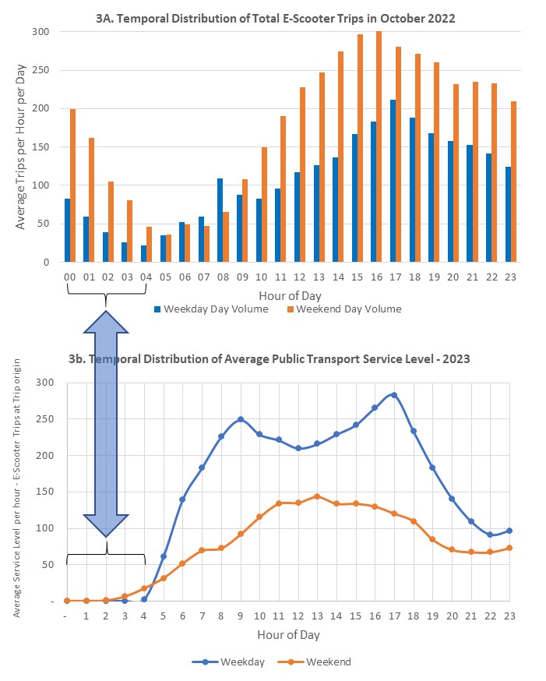

Figure 3: Temporal Distribution of E-scooter Demand and Public Transport Service Level

## Spatial analysis of e-scooter demand and relative service levels

Figure 4 illustrates the spatial distribution of total e-scooter travel volume for October 2022 (Figure 4a. total trips and Figure 4b. trip density) against the spatial distribution of total public transport service level. In each case quintiles are used to determine the shading in the choropleths in the maps.

Total e-scooter trip volume (Figure 4a)

The highest volume areas of travel (red) are concentrated in the CBD/downtown area with a high volume along the southern edge of the CBD following the path of the Yarra River between Docklands to the west and the sporting precincts (where several sporting stadiums lie) to the east.

There is also a high trip volume in the south of the map along Port Phillip Bay in the suburb of St Kilda. Both of these high-volume locations have popular off-road cycle paths and are tend to attract tourist. They both feature impressive views along the river/bay area. For the area south of the CBD, note that transit services are radial (feeding into the CBD) with no east-west services south of the Yarra River.

The second highest trip volume quintiles (darker orange) lie on major CBD access corridors and are also larger zones. Low volume e-scooter travel zones tend to lie in relatively suburban parts of inner Melbourne.

E-scooter trip density (Figure 4b)

This graphic removes the volume bias which occurs with larger zones found in Figure 4a. E-scooter trip concentration is significantly lower for larger zones in Figure 4b compared to Figure 4a. The overall result of this perspective is to highlight the concentration of e-scooter travel in the CBD/Downtown area; in this case the whole CBD area is highlighted as a top travel category in addition to the east west south CBD strip which is the only part highlighted in Figure 4a. Locations to the north of the CBD (North Melbourne, Carlton, Collingwood and Fitzroy) are also highlighted as hotspots for high density of e-scooter travel as well as sections of South Melbourne and along a major arterial road into the city from the south (St Kilda Road). These high-concentration areas tend to overlap with tram routes, and are higher than similar areas that are served by train stations. Figure 4b also highlights the zones along the bayside sea front to the south as high-density e-scooter trip zones. In general, public transport is limited along this section but the bay views, a bayside cycle path and tourism visitation potential is high along this coastal area.

Public Transport Service Level (Figure 4c)

The highest service level zones are around the CBD area and areas adjacent to the CBD on the Northern, Southern and Eastern boundaries. St Kilda Road (South East of the CBD) is also a service level hotspot; this is where multiple tram routes converge to run a very high frequency service. Second tier service level zones are contiguous to these hotspots. St Kilda is also highlighted as a ‘second quintile’ service level zone.

Comparing the spatial spread of service level and e-scooter use (Figure 4 as a whole)

All measures of the spread of e-scooter travel generally match the concentration of transit service level in Melbourne CBD, and the relationship between trip volume (Figure 4a) and SI score (Figure 4c) is statistically significant (S=6.03×107, p<0.001, pSpearman=0.31, CI95%[0.25,0.38], npairs=808). The relationship between trip density (Figure 4b) and SI score (Figure 4c) is also statistically significant (S=3.06×107, p<0.001, pSpearman=0.65, CI95%[0.61,0.69], npairs=808), and appears more closely match with the spatial concentration of service, notably in the CBD and adjacent suburbs to the South, North, East and West of the city.

However, the transit service index masks a few deeper considerations of the potential relationships between e-scooter use and transit. As noted, there are no east-west transit connections south of the Yarra River even though this corridor connects multiple attractors (Convention and Exhibition Centre, Crown Casino, the arts precinct and the sporting precinct). E-scooters could be filling a *directional* service gap.

In addition, concentration of e-scooter use appears to be higher in the inner north where transit SI is notionally very high, but provided by trams that share road space with private vehicles. So, although the quantum of service may be high, this does not take into account congestion, reliability or crowding, all of which may degrade the quality of service in these areas. There is also a reasonable network of painted and separated bike lanes in the inner north of Melbourne, further increasing the attractiveness of e-scooters.

The bayside concentration of e-scooter use may also be compensating for a *directional* service gap, as several of the tram services here feed into the CBD. However, lack of public transport service is not the only reason for concentration of e-scooter travel in these zones; an attractive and safer coastal cycle path is another reason to travel by e-scooter in these areas.

Zones to the west of the CBD represent the Port of Melbourne and heavy industrial land uses; both transit service and e-scooter concentration in these areas is quite low.

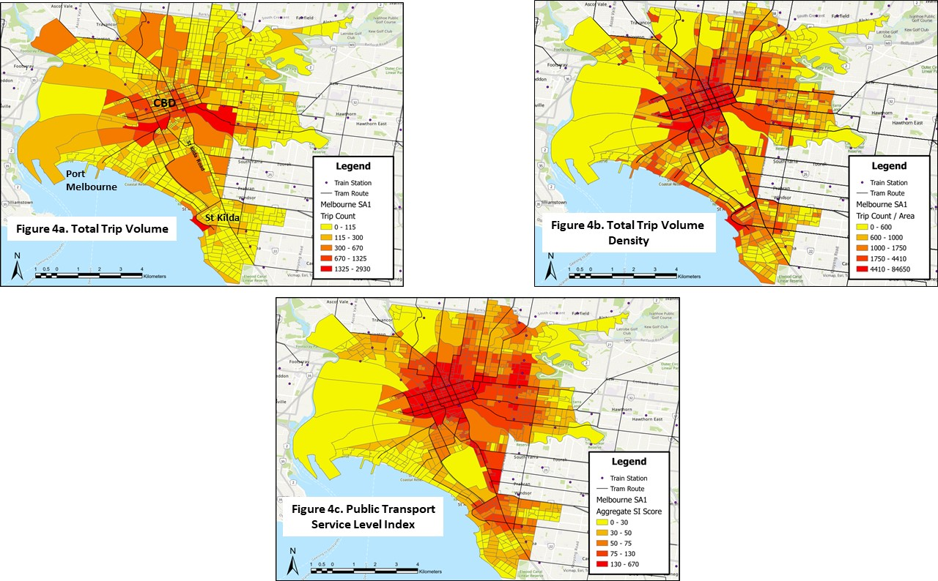

Figure 4: Spatial Distribution of E-scooter Demand and Public Transport Service Level

Overall, this analysis shows mixed evidence of e-scooter use as a means to fill spatial gaps in transit service. The dominant pattern is the co-location of high transit service levels in Melbourne CBD with high e-scooter trip volume concentration. However, there is some evidence that e-scooters could be filling directional service gaps (e.g. orbital trips in sections with radial transit service) and that e-scooters may be competing with tram services more than train services.

## Identifying E-scooter Trips to/from Rail Stations

It is not possible to directly identify from the raw data if e-scooter riders used transit as part of their trip. Instead, it was assumed that e-scooter trips starting or ending within 30 meters of a rail station entrance/exit were connected to transit. This 30-meter threshold was determined based on site observations at several inner Melbourne stations; arriving/departing e-scooter users tended to have trip ends within a maximum of 30 metres from the exit.

This approach to defining rail related travel is certainly only an approximation; it is quite possible some e-scooter users parking within the 30-metre radius do not use rail and also that others outside the threshold use rail. Nevertheless, it was considered ‘reasonable’ to assume the 30 metres threshold to explore likely e-scooter rail related travel behaviour.

For this analysis, we did not consider the distribution of trips within 30 meters of tram or bus stops.

### Rail Related E-Scooter Trip Volume and Distance

Table 1 shows the number and types of rail-related trips resulting from this analysis. It also shows average e-scooter trip distances. This suggests that:

* Rail related e-scooter travel is between 6-7% of all e-scooter use. A slightly higher share of e-scooter travel to rail occurs during weekdays than weekend days.
* Slightly more trips started at stations (3,295, 3.4% of 95,157) than ended at stations (3,197, 3.3%), but this difference was not statistically significant (χ2Pearson(1)=1.53, p=0.22), VCramer=1.64 ×1010), CI95%[0.00 1.00], nobs=196,708), nor was there a statistically significant relationship between whether a trip ended at a station if it started at a station (388 of 3,295, 10%) or if it started somewhere else (2,859 of 95,059, 3%)(χ2McNemar(1)=1.65, p=0.20), gCohen=8.43 ×10-3), CI95%[-4.42×10-3, 0.02], npairs=98,354).
* There was a small, but statistically significant, difference between the rate at which trips started at stations on weekdays (1,917 of 55,293, 3.6%) compared to weekends (1,378 of 41,683, 3.2%) (χ2Pearson(1)=5.32, p=0.02), VCramer=6.63 ×10-3), CI95%[0.00 1.00], nobs=98,354). As well there was a similarly small, but statistically significant, difference for the rate of trips ending at stations on weekdays (1,888, 3.4%) compared to on weekends (1,309, 3.0%) (χ2Pearson(1)=10.81, p<0.01), VCramer=9.98×10-3), CI95%[4.15×10-3, 1.00], nobs=98,354). The slightly lower rates on weekends might be reflective of the lower transit service levels on weekends, meaning that there is less reason to start or end a trip at a station.
* E-scooter trips that start *and* finish at stations are very uncommon (338 trips, 0.4%), and there is no statistically significant variation in their rate on weekdays versus weekends (χ2Pearson(1)=2.04, p=0.15), VCramer=3.26×10-3), CI95%[0.00, 1.00], nobs=98,354).
* There is a statistically significant difference in length for rail-related trips between weekends and weekdays (WMann-Whitney=4.16×106, p<0.001), r(rank, biserial)=-0.09), CI95%[-0.12, -0.06], nobs=6,154), with weekend trips slightly longer (average 2.0kms, median 1.5kms) than weekdays (average 1.8kms, median = 1.3kms). For non-rail-related trips there is also a statistically significant difference in trip length (WMann-Whitney=1.01×109, p<0.001), r(rank, biserial)=-0.04), CI95%[-0.05, -0.03], nobs=92,200), again with weekend trips appearing to be slightly longer (median 1.4km versus 1.3km)
* There is no significant difference in the length of rail-related and non-rail-related e-scooter trips (WMann-Whitney=2.83×108, p<0.58), r(rank, biserial)=-4.21×10-3), CI95%[-0.02, 0.01], nobs=98,354.

Table : Rail related E-Scooter Trip Volume and Average Distance (Km)

|  |  |  |  |  |  |  |
| --- | --- | --- | --- | --- | --- | --- |
| **Case** | **Start at Rail Station** | **End at Rail Stations** | **Between**  **Rail Stns** | **Total Rail related** | **Total All Trips** | **%** |
| **Weekdays (n)** | 1,917 | 1,888 | 29 | 3,628 | 55,293 | 6.6% |
| **(%)** | 53% | 52% | 1% |  |  |  |
|  |  |  |  |  |  |  |
| **Av Distance (km)** | 1.670 | 1.711 | 1.184 | 1.715 | 1.778 |  |
|  |  |  |  |  |  |  |
|  |  |  |  |  |  |  |
| **Weekend Days (n)** | 1,378 | 1,309 | 69 | 2,526 | 43,293 | 5.8% |
| **(%)** | 55% | 52% | 3% |  |  |  |
|  |  |  |  |  |  |  |
| **Av Distance (km)** | 1.938 | 1.942 | 0.922 | 2.000 | 1.988 |  |

The analysis suggests rail related e-scooter trips are about 6-7% of all e-scooter travel in Melbourne. This is estimate is much lower than what was identified in user surveys, whereby 37% of trips connected to transit. Since rail tends to dominate inner-city public transport ridership, the 6-7% estimate is almost certainly an under-estimate.

### Rail Related E-Scooter Temporal Trip Distribution

Figure 5a illustrates the average hourly volume of e-scooter rail-related trips for weekdays/weekend days. It also shows these as a share of total e-scooter travel. Figure 5b shows the average hourly service level SI scores for comparison. This indicates that:

* Hourly station e-scooter use is highest in volume at weekends than weekdays; this contrasts to total e-scooter volume (Figure 3) which is much higher during weekdays.
* Rail related e-scooter travel as a share of total e-scooter travel is highest in the hours before the weekday morning peak (4a.m. to 8a.m.). However, total e-scooter travel is quite small at this time (Figure 3) hence the actual volume of pre-a.m. peak e-scooter rail-related trips is quite small.
* In general, rail related e-scooter travel as a share of total e-scooter travel is quite flat over time; between 4% and 8% on both weekdays and weekend days with the exception of the weekday pre-morning peak hours.
* There are no obvious links between service level (Figure 5b) and rail related e-scooter travel over the day.

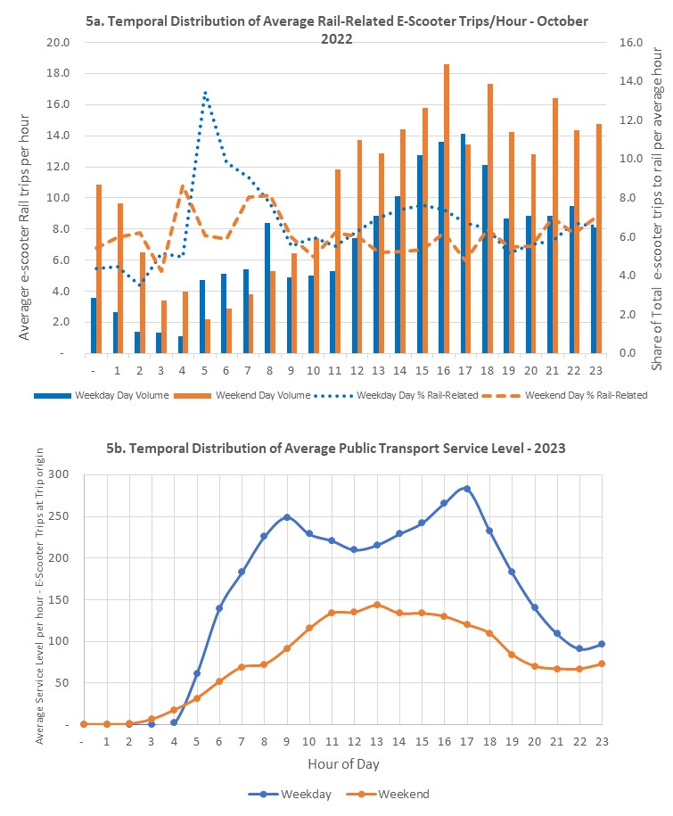

Figure 5: Temporal Distribution of Rail Related E-scooter Demand and Public Transport Service Level

### Rail Related E-Scooter Spatial Trip Distribution

Figure 6 explores the spatial distribution of total rail related e-scooter trip ends (Figure 6a) and the share of trip ends (Figure 6b) of all e-scooter trips for the data in October 2022[1]. It also compared this to the service level plot (Figure 6c). This indicates that:

* Rail related e-scooter trip volume of travel (Figure 6a) at the highest volume (red) are concentrated around inner CBD major rail stations; notably Flinders Street Station, Southern Cross Station, Richmond Station and Melbourne Central. These are the highest volume stations. Since e-scooter trips are only about 1.7-2.0kms long this seems to make a lot of sense.
* In general, the lowest levels of trip volume are in areas further away from rail stations; medium trip volumes are contiguous between low and high-volume zones.
* The spatial distribution of share of rail trips by zone (Figure 6n) suggests a wider spread of zones around stations; in addition to the CBD stations, less CBD centric zone clusters around Kensington, Parkville, Clifton Hill, North Richmond, Richmond, the Sports Precinct, the Botanic Gardens and Ripponlea are highlighted as high share zones. A likely feature of these non-CBD high share clusters is that they have less total e-scooter trips (see Figure 4a) hence the rail related trips they get represent a higher share of trips.
* Fishermans Bend stands out as a medium level e-scooter rail-related trip share zone but is very far from the CBD and has the lowest public transport service level (Figure 6c). This seems likely a case where e-scooters are used from low transit service level areas as a mode to access from or egress to rail. This would represent a significant length of rail access/egress trip well above the average e-scooter trip length of 1.7-2kms.
* In general, the spatial distribution of all mode service level (Figure 6c) supports a link of high service level zones for rail in the CBD being related to high e-scooter rail access volume and share. Statistical analysis indicates a significant relationship between SI score and rail-related trip volumes (S=5.40×107, p<0.001, pSpearman=0.39, CI95%[0.32,0.44], npairs=808) and between SI score and the probability of a trip involving a rail connection (S=6.53×107, p<0.001, pSpearman=0.26, CI95%[0.19,0.32], npairs=808). However, Fishermans Bend, Flemington, Kensington, Parkville and Ripponlea appear to be exceptions; and these may represent suburbs where e-scooters act as a first-last mile rail access/egress mode.

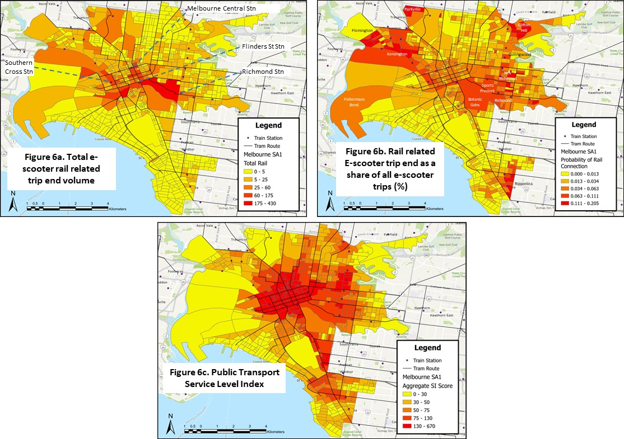

Figure 6: Spatial Distribution of Rail Related E-scooter Demand and Public Transport Service Level (October 2022)

## Change in Transit service level score between e-scooter trip ends

One way to explore how transit service level relates to e-scooter trips is to understand the relative difference between the transit service level at one end of the trip compared to service level at the other end of the trip. In theory, e-scooter trips that perform a transit first-last mile function should be going from a low service level area to a high service level are and vice-versa for the return trip. Hence the difference in service level scores between trip ends can act as an indicator for first-last mile trips.

Figure 7 shows the temporal distribution of average percentage difference in service level (SI) score by hour for weekday and weekend trips.

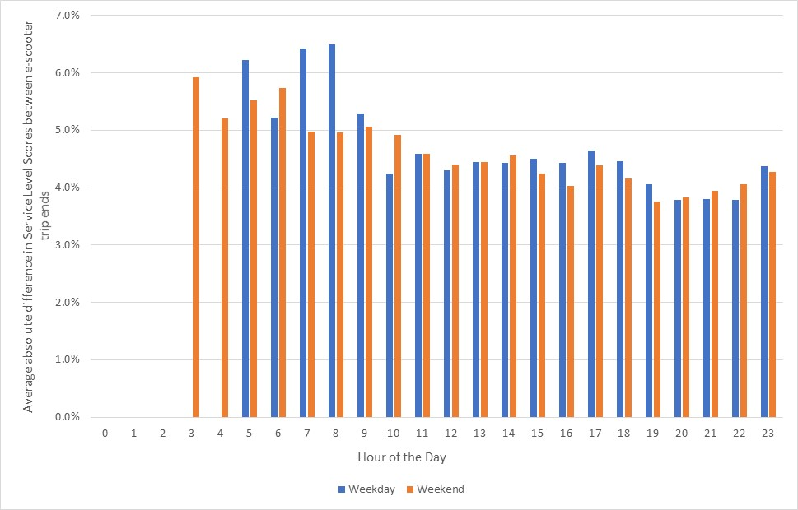

Figure 7: Temporal distribution of the perentage difference in average service level (SI) scores between each trip end of all e-scooter trips

Figure 7 indicates that:

* As a percentage, the average difference in service level scores of all e-scooter trips is not very high; its between 4 and 7%. This reflects the high concentration of trips in high service level zones and suggests limited e-scooter travel to low service level areas.
* The highest percentage differences in e-scooter trip end transit service level scores are in the early hours of the day; between 3a.m. and 8 a.m. These high difference values are larger on weekdays and coincide with the times when there is a significantly high volume of e-scooter trips (Figure 3a) and very low transit service level (Figure 3b). This is also the time where the share of rail related e-scooter trips is highest (Figure 5a).
* After 8a.m. and for the rest of the day; the percentage absolute difference in trip end service level is relatively constant and and quite small; around 4%.

Figure 8 explores if the differences in service level between e-scooter trip ends is difference for rail related trips compared to non-rail related trips. It also explores if this varies by e-scooter trip length.

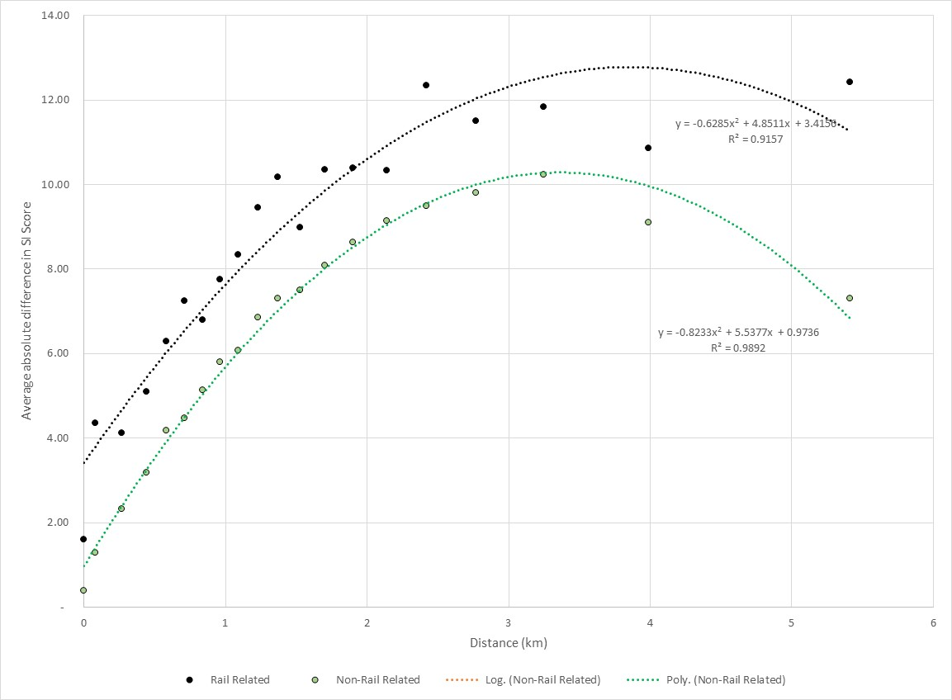

Figure 8: Absolute difference in average service level (SI) scores between each trip end of all e-scooter trips and its variation with e-scooter trip length (km)

Figure 8 indicates that:

* The absolute difference in average service level scores are larger for rail-related trips compared to non-rail related trips[2]. This implies that rail-related trips involve a degree of travel to/from high service level zones (the station) to/from lower service level zones. This matches a first-last mile trip role profile.
* Service levels for both rail and non-rail related e-scooter trips generally increase with distance[3], although this pattern is not present in trips longer than 3kms. Instead, there is a negative relationship between distance and absolute change in SI score for all trips that are longer than 3kms and for non-rail-related trips longer than 3kms[4]. However, trips over 3kms make up only around 17% of trips.

While e-scooter average difference in trip end service level increases with distance (Figure 8) there is much scatter in actual service levels scores around the mean. A regression of actual rail related scores against trip distance provided a best fit R2 value of0.11 suggesting only 11% of the variation in rail related differences in trip end service level scores can be explained by trip distance. Clearly there are many factors than just service level and distance impacting e-scooter rail-related trips.

# Discussion and Conclusions

This paper explores links between the spatial and temporal patterns of e-scooter use and how this relates to public transport in inner cities, particular in relation to the level of service provided by public transport. The research has an interest in the degree of complementary and competitive roles which e-scooters play in relation to public transport. It tests the hypothesis that e-scooter use is stronger in areas where inner area transit offers a poorer quality service. The implication of this hypothesis is that e-scooters may be a ‘gap filler’ in inner area travel providing first-last mile access to transit.

Key findings of our e-scooter trip patterns and transit service level analysis are that:

* The strongest evidence of ‘gaps’ in transit service level where e-scooter use is high are from the temporal analysis (Figure 3); between midnight and 5a.m. on both weekday and weekend days a substantial e-scooter demand is apparent at times when transit service is unavailable. This represents 10% of all weekday and 15% of all weekend day e-scooter travel.
* E-scooter demand is also highest at weekends when transit service levels are lower.
* In general, spatial patterns of e-scooter demand (Figure 4) show strong positive correlations with transit service levels, notably in CBD areas and around CBD major rail stations. There are some spatial gaps in service levels where e-scooter demand density is high and service level low; notably along the bayside ‘strip’ of land between Port Melbourne and St Kilda. While this might represent a first-last mile transit area; high e-scooter use in this area may be due to its sea views and beaches plus the high-quality exclusive bike lane this area enjoys along its full length.
* E-scooter trip ends within 30 metres of rail station access points represented 6-7% of all e-scooter trips. Slightly less occur at weekends in contrast to total e-scooter travel which is larger at weekends.
* Typical trip lengths are 1.7-2km, much the same as non-rail related trips.
* Rail related e-scooter travel also demonstrates a demand between midnight and 5a.m. when average transit service levels are low. However, this represents a much smaller share of all day e-scooter rail related travel; 1% on both weekdays and weekend days. This contrasts with the total e-scooter travel between midnight and 5a.m. (10% weekday and 15% weekend day). The obvious explanation for this is early hour rail service levels at stations; very little and basic service is provided making rail feeder functions less attractive.
* Rail related e-scooter trips as a share of total e-scooter demand is quite flat during the day (4-8%) with the exception of the weekday pre-morning peak hours of 5-6a.m. where it represents up to 16% of all e-scooter travel. This suggests an early morning access peak to/from stations for early start employees such as building workers travelling from rail stations to sites within the city. Although this is a big share of e-scooter travel at that time, total e-scooter travel then is very small, so it is not a very high total demand.
* The spatial distribution of rail-related e-scooter trip volume is highly focussed on CBD major rail stations of Flinders Street, Melbourne, Central, Southern Cross and also Richmond (Figure 6a). The share of all e-scooter trips which are rail-related show a wider spread; less CBD centric zone clusters around Kensington, Parkville, Clifton Hill, North Richmond, Richmond, the Sports Precinct, the Botanic Gardens and Ripponlea are highlighted as high share zones. A likely feature of these non-CBD high share clusters is that they have less total e-scooter trips (see Figure 4a) hence the rail related trips they get represent a higher share of trips.
* Fishermans Bend stands out as a medium level e-scooter rail related trip share zone, but is very far from the CBD and has the lowest public transport service level (Figure 6c). This seems likely a case where e-scooters are used from low transit service level areas as a mode to access from or egress to rail. This would represent a significant length of rail access/egress trip well above the average e-scooter trip length of 1.7-2kms.
* The difference in transit service level score between e-scooter trip ends was explored to test the hypothesis that high differences are indicative of first-last mile trips between high service level stations and low service level suburbs (and vice versa). The average difference in trip end scores were small (of the order of 4%) suggesting first-last mile trip patterns are not widely spread. Interestingly average differences were larger between 3 to 8a.m. where high levels of e-scooter trips occur (midnight to 4 a.m.) and also when the high share of e-scooter rail related trips occur (8a.m.). Analysis also suggested that average differences in service levels between e-scooter trip ends increases with trip distance. Also in general, rail related trips had higher differences in trip end service level scores than non-rail related trips; suggesting some evidence of a first-last mile role for rail related trips; however given the size of these differences; the scale of this role seems small. It is however interesting that average differences are larger for longer rail related e-scooter trips. However in practice actual scores show much scatter around the mean; a regression of scores against distance suggested distance explained only 11% of variation in differences in trip end scores.

Overall, we find e-scooter demand is highly concentrated in areas and at times when transit service levels are highest. This is suggests a more competitive role for e-scooters, rather than complementary with public transport. In general, we therefore conclude that the widespread application of the hypothesis that e-scooters always act as a ‘gap filler’ for areas of low transit and that first-last mile to transit behaviours dominate is disproven.

Nevertheless, we have found limited and specific evidence of times and areas where ‘gap filling’ and first-last mile trips are apparent. Early hour e-scooter travel is a reasonably share of the market (10-15%) and its link to lack of transit at these times is a clear rationale for these trips. Alternatives at this time such as taxis may also be expensive. Higher e-scooter travel at weekends may also be linked to lower transit service level. Spatial gaps in transit where e-scooter may be a gap filler were harder to identify. Of these Fishermans Bend (Figure 6b) for long rail related e-scooter trips is the most obvious. High shares of rail related e-scooter trips around non-CBD areas of Kensington, Parkville, Clifton Hill, North Richmond, Richmond, the Sports Precinct, the Botanic Gardens and Ripponlea are others. The generally higher differences between service level at e-scooter trip ends for rail related trips is also suggestive of a larger first last mile function for these trips; though its scale is not large.

So, what are the implications of these findings for planning practice. Most findings suggest an overlap between e-scooter travel and transit service level and hence capacity. This is problematic from a government pricing perspective because transit is heavily subsidised due to congestion relief, environmental and social benefits. E-scooters competing with transit act to erode farebox revenue and hence increase the subsidies needed; it may also represent ‘over-supply’ and potential congestion in busy CBD areas. A counter argument is that inner area transit, notably trams, are very highly crowded in inner areas and that e-scooters might act a form of crowding relief for trams. A further consideration is that users have actively chosen to use e-scooters over transit implying they see consumer benefits.

We have found some, though limited, evidence that e-scooters act as a first last mile mode providing a gap filler role to access areas and times when transit is not provided. This provides strong support for e-scooters to improve inner area mobility supporting transit as the larger distance sustainable travel alternative. Policy should seek to enhance e-scooters in this area implementing measures such as joint ticketing, information and marketing programs including e-scooter parking areas at transit stops (none of which are current policy in Melbourne).

There are many limitations to this research; the aggregation of analysis to SA1 levels removes much detail in trip patterns and could be further explores in future research. The designation of rail-related trips using the 30 meters station entrance threshold is clearly only an approximation. Ideally future trip data would be linked to user surveys such that actual trip ends for all transit related trips (all modes) could be better understood. The focus of this analysis on rail-only transit is also limiting; analysis of bus and tram related e-scooter travel is a worthwhile area for future research.

Overall, it is clear that e-scooters are providing value to inner area travellers however their role in supporting (complementing) transit as a first-last mile feeder seems limited. Future research and practice should seek to improve the integration of micromobility with transit to improve the sustainability of future transport.

# References

Aarhaug, J., Fearnley, N. & Johnsson, E. 2023. E-scooters and public transport – Complement or competition? *Research in Transportation Economics,* 98.

Bozzi, A. D. & Aguilera, A. 2021. Shared E-Scooters: A Review of Uses, Health and Environmental Impacts, and Policy Implications of a New Micro-Mobility Service. *Sustainability,* 13**,** 8676.

Curl, A. & Fitt, H. 2020. Same same, but different? Cycling and e‐scootering in a rapidly changing urban transport landscape. *New Zealand Geographer,* 76**,** 194-206.

Currie G 2010. Quantifying spatial gaps in public transport supply based on social needs. *JOURNAL OF TRANSPORT GEOGRAPHY* 18 (2010) 31–41

Jayawardhena M, Delbosc A & Currie G 2024 Under Review. Exploring the Melbourne e-scooter market and its links to public transport. *Australasian Transport Research Forum.* Melbourne, Australia.

Kazemzadeh, K., Haghani, M. & Sprei, F. 2023. Electric scooter safety: An integrative review of evidence from transport and medical research domains. *Sustainable Cities and Society,* 89**,** 104313.

Luo, H., Zhang, Z., Gkritza, K. & Cai, H. 2021. Are shared electric scooters competing with buses? a case study in Indianapolis. *Transportation Research Part D: Transport and Environment,* 97.

Manning, R. & Babb, C. 2023. Micromobility for first and last mile access to public transport: institutional perspectives from Perth, WA. *Australian Planner,* 59**,** 89-100.

Melbourne City Council. 2024. *E-scooter trials in Victoria* [Online]. Available: <https://www.melbourne.vic.gov.au/parking-and-transport/Pages/e-scooters.aspx> [Accessed 15-03-2024 2024].

Tyndall, J. 2022. Complementarity of dockless mircomobility and rail transit. *Journal of Transport Geography,* 103.

Ziedan, A., Shah, N. R., Wen, Y., Brakewood, C., Cherry, C. R. & Cole, J. 2021. Complement or compete? The effects of shared electric scooters on bus ridership. *Transportation Research Part D: Transport and Environment,* 101.

Zuniga-Garcia, N., Tec, M., Scott, J. G. & Machemehl, R. B. 2022. Evaluation of e-scooters as transit last-mile solution. *Transportation Research Part C: Emerging Technologies,* 139.

1. Note: Choropleths of trip volume (Figure 6a) and share of rail related trips (Figure 6b) are determined using a natural breaks method of the distribution of these variables
2. There is a statistically significant difference in the absolute difference in SI Score between the rail (mean = 120.1, n = 6,154) and non-rail-related (mean=89.2, n= 92,200) trips (tWelch (6,915.22)=-14.97, p<0.001, gHedges = -0.20, CI95%=[-0.23, -0.17], nobs = 98,354.
3. There is a statistically significant relationship between trip distance and absolute difference in SI score across: all trips (S=1.08×1014, p<0.001, pSpearman=0.32, CI95%[0.31,0.32], npairs=98,354); rail-related trips (S=2.84×1010, p<0.001, pSpearman=0.27, CI95%[0.24,0.29], npairs=6,154); and non-rail-related trips (S=8.88×1013, p<0.001, pSpearman=0.32, CI95%[0.31,0.33], npairs=92,200).
4. For trips over 3kms there is a statistically significant (and negative) relationship between trip distance and absolute difference in SI score across: all trips (S=8.89×1011, p<0.001, pSpearman= -0.08, CI95%[-0.09,-0.06], npairs=17,042); and non-rail-related trips (S=7.51×1011, p<0.001, pSpearman=-0.09, CI95%[-0.10, -0.07], npairs=16,070). The relationship is not significant for rail-related trips longer than 3km (S=1.46×108, p<0.14, pSpearman=0.05, CI95%[-0.02, 0.11], npairs=972). For trips less than or equal to 3km in length the relationship between distance and absolute change in SI score is statistically significant for all trips (S=5.75×1013, p<0.001, pSpearman=0.36, CI95%[0.35, 0.36], npairs=81,312); non-rail-related trips (S=4.68×1013, p<0.001, pSpearman=0.36, CI95%[0.36, 0.37], npairs=76,130); and rail-related trips (S=1.68×1010, p<0.001, pSpearman=0.28, CI95%[0.25, 0.30], npairs=5,182).